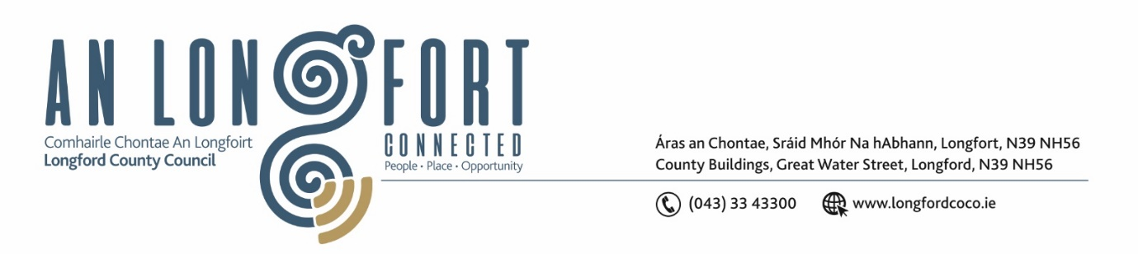

***Please note meeting will be held in the Council Chamber and via Microsoft Teams.***

1 June 2022.

**Chuig: Gach Ball don Chomhairle.**

A Chomhairleoir,

Iarrtar ort bheith i láthair ag Cruinniú Míosuil Chomhairle Chontae Longfoirt a tionólfar i Seomra na Comhairle, Aras an Chontae, Longford agus via MS Teams are an **Chéadaoin 8ú Mí Meitheamh 2022 ag** **3pm** chun gnó a dhéanamh d’réir an Chláir thíos.

You are requested to attend the Monthly Meeting of Longford County Council to be held in the Council Chamber and **via Microsoft Teams** on **Wednesday 8 June 2022 at 3pm** to transact business, as set out on the Agenda hereunder.

Mise le meas,

*Ann Marie Mc Keon*

**__________________**

**Ann Marie Mc Keon**

**Meetings Administrator.**

**C L Á R**

Prayer before meeting.

**1.** Confirmation of Minutes of Monthly Meeting of Longford County Council held on 11 May 2022– copy enclosed.

**2.** Matters Arising.

**3.** Declaration of Interest by Members.

**4.** To note Management Report – to follow.

**5.** To note adopted Minutes of Corporate Policy Group Meeting held on the

11 April 2022 – enclosed.

**6. Planning and Project Delivery**

**(a)** To note Planning Applications received since last meeting of the Council.

**7. Community, Corporate and Enterprise**

**(a)** Consideration and adoption of Draft Annual Report 2021 prepared in

accordance with Section 221 of Local Government Act 2001 as amended –

copy of updated draft report to follow.

**8. Infrastructure, Housing and Innovation**

**(a)** Notice of Motions, submitted by Councillors, as listed hereunder –

**Councillor Pat O’Toole**

“I call on the Minister for Housing, Local Government and Heritage to remove the population cap on the Affordable Homes aspect of the Housing for All Rebuilding Ireland Plan to allow towns like Edgeworthstown, Ballymahon and Granard to be included in the Scheme.”

**Councillor Paul Ross**

That Longford County Council prepare a tender for contractors to apply to refurbish our reletting housing stock to try and deal with the huge backlog in getting our council houses refurbished and reoccupied by new tenants.

**9. General**

**(a)** Notice of Motions, submitted by Councillors, as listed hereunder –

**Councillor Paul Ross**

That Longford County Council calls on the Minister for Health to move the Tobacco and Nicotine inhaling products bill into law as soon as possible in order to regulate the sale of vaping products in Ireland.

**10. Correspondence**

Letter dated 9 May 2022 from Office of the Tánaiste – Re Turf Cutting – enclosed.

**11. Training – enclosed.**

**12. Votes of Sympathy**